Migration Camunda Application
Step-by-Step Migration Guide:
- Assessment and Planning
- Inventory Applications: List all applications, their dependencies, and configurations.
- Define Objectives: Determine the goals of migration (e.g., scalability, maintainability).
- Stakeholder Alignment: Ensure all stakeholders are informed and aligned with the migration plan.

- Infrastructure Preparation
- OpenShift Setup: Prepare your OpenShift environment for deployment.
- Helm Installation: Install Helm on our local machine and OpenShift cluster.
- AWS RDS Configuration: Set up AWS RDS instances with appropriate configurations.

- Application Containerization
- Dockerized Applications: Create Docker images for your Spring Boot applications.
- Helm Chart Creation: Develop Helm charts for deploying applications on OpenShift.
- JFrog Artifactory Integration: Push Docker images to JFrog Artifactory for version control.

- CI/CD Pipeline Setup
- Bitbucket Integration: Integrate Bitbucket repositories with your CI/CD tools.
- Bamboo Configuration: Set up Bamboo plans for building, testing, and deploying applications.
- Automated Testing: Implement automated tests to ensure application stability post-migration.
AWS Documentation
- Database Migration
- Schema Migration: Use tools like Liquibase or Flyway to manage database schema changes.
- Data Migration: Transfer existing data to AWS RDS instances securely.
- Validation: Verify data integrity and application connectivity to the new databases.

- Camunda Integration
- Version Compatibility: Ensure Camunda versions are compatible with the new environment.
- Process Deployment: Deploy BPMN processes to the Camunda engine within OpenShift.
- Testing: Run test cases to validate process executions and integrations.

- Monitoring and Logging
- Set Up Monitoring Tools: Implement monitoring solutions to track application performance.
- Logging Configuration: Configure centralized logging for easier troubleshooting.
- Alerts and Notifications: Establish alerting mechanisms for critical issues.

- Final Validation and Go-Live
- User Acceptance Testing (UAT): Conduct UAT to ensure applications meet business requirements.
- Performance Testing: Test application performance under load conditions.
- Go-Live: Deploy applications to the production environment.
https://camunda.com/platform-7/migrate/?utm_source

---- Started Migration 06-06-2025----
We are taking the backup to the old prelive cluster and put into the new cluster.
Step – 1: We need login using oc login command to the PowerShell. First, we need login to the old prelive cluster and take backup with configMaps using the below command.
oc get configmaps -n prelive -o yaml > source-preliveconfigmaps-backup.yaml
- This command is used with OpenShift CLI (oc) to export the configuration maps from a specific namespace into a YAML file.
- oc: This is the OpenShift CLI tool, used to interact with an OpenShift cluster.
- get configmaps: This tells OpenShift to list all ConfigMaps in the specified namespace. ConfigMaps are used to store configuration data (like environment variables or config files) in key-value format.
- -n prelive: Specifies the namespace as prelive.
- -o yaml: Outputs the result in YAML format.
- >: This is a shell redirection operator. It redirects the output of the command (the YAML-formatted ConfigMaps) into a file.
- source-preliveconfigmaps-backup.yaml: This is the filename where the output is saved in the current directory.
It retrieves all ConfigMaps in the prelive namespace, converts them to YAML format, and saves them into a file named source-preliveconfigmaps-backup.yaml. This is typically done for backup or migration purposes.
Step – 2: ----get all configmaps
oc get configmap -n camunda-prelive -o yaml > prelive_all_configmaps.yaml
- get configmap:
  - This retrieves ConfigMaps.
  - We can use configmap (singular) or configmaps (plural); both are accepted by OpenShift/Kubernetes.
- -n camunda-prelive: Specifies the namespace you want to pull the ConfigMaps from — here, it's camunda-prelive.
- -o yaml: Tells OpenShift to output the ConfigMaps in YAML format.
- >: Redirects the output to a file.
- prelive_all_configmaps.yaml: The name of the file where all ConfigMap data will be saved.
What the Command Does:
It fetches all ConfigMaps from the camunda-prelive namespace, formats them as YAML, and saves them into the file prelive_all_configmaps.yaml.
This is commonly used for:
- Backup
- Migration to another cluster
- Version tracking or comparison
Optional: If want each ConfigMap separated clearly in the YAML (e.g., for easier parsing or restoring), might prefer:
oc get configmap --all-namespaces -o yaml > all_configmaps.yaml.
Step – 3: ---restore
oc apply -f prelive_all_configmaps.yaml
- apply: This command creates or updates Kubernetes/OpenShift resources based on a configuration file.
- -f prelive_all_configmaps.yaml: Specifies the file (prelive_all_configmaps.yaml) that contains the YAML definition of one or more ConfigMaps.
Create or update all the ConfigMaps defined in prelive_all_configmaps.yaml in their respective namespaces (if specified inside the YAML) or in the current context's namespace.
Important:
- If namespace is missing in the YAML, it uses your current namespace.
- It will update existing ConfigMaps and create new ones.
- Make sure the YAML is valid and uses --- to separate multiple resources.
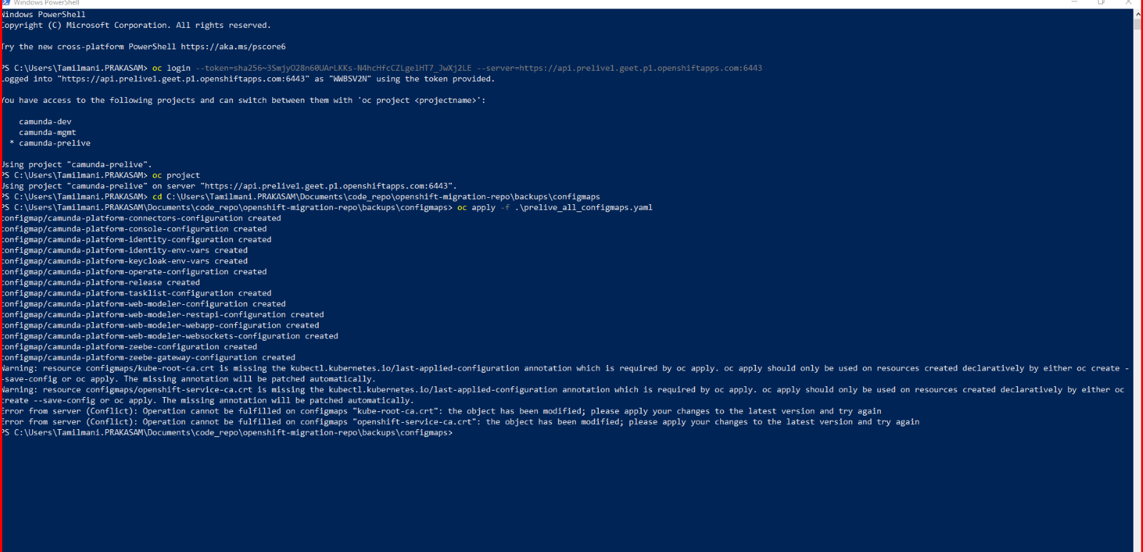
Same procedure we have follow the secrets as well:
Secrets:
Step – 1: --backup
oc get secrets -n camunda-prelive -o yaml > prelive_all_secrets.yaml
Step – 2: ---restore
oc apply -f prelive_all_secrets.yaml

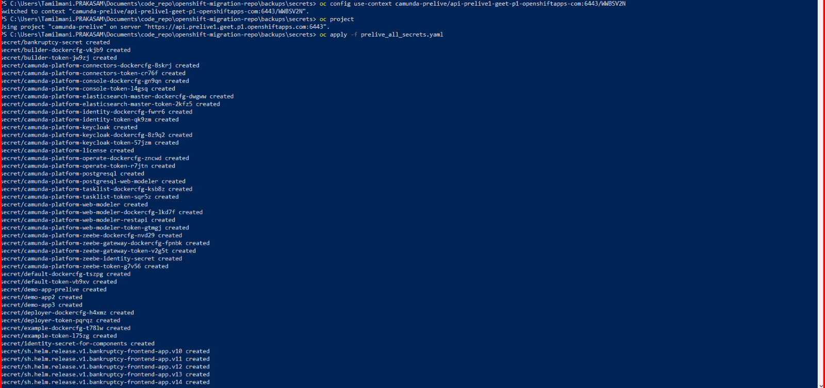

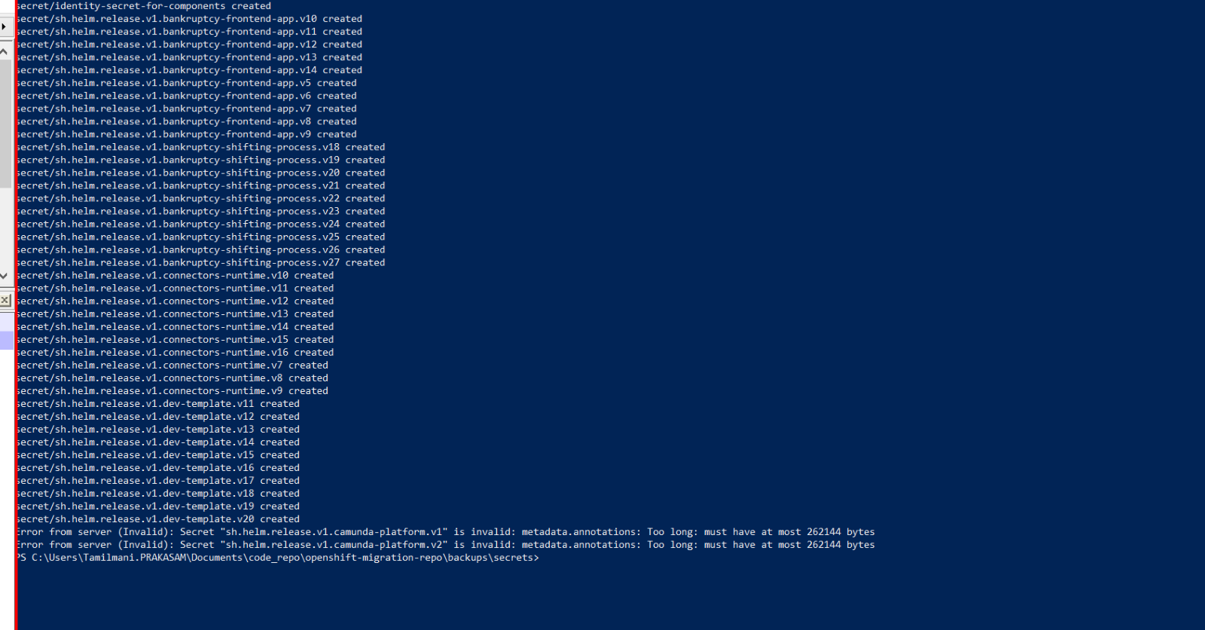
Openshift Context:
When using PowerShell to execute oc commands, we can switch from the old cluster to the new cluster within the same PowerShell session. However, if we open a different PowerShell window, we might face issues because the oc CLI maintains context globally for the user, and different sessions might not share the same configuration or context.

---new cluster
oc config use-context camunda-prelive/api-prelive1-geet-p1-openshiftapps-com:6443/WWBSV2N
----old cluster
oc config use-context camunda-prelive/api-prelive-kubika0-q8u7-p1-openshiftapps-com:6443/WWBSV2N

--------------Migrate UserManagement(ServiceAccounts, Roles, RoleBindings)------------
Migrating User Management objects — specifically ServiceAccounts, Roles, and RoleBindings — is critical to ensure that your workloads in the new OpenShift cluster continue to have the same permissions and identity context as they did in the old cluster.
Below is a detailed guide and best practices for migrating:

Objective:
Migrate:
- ServiceAccounts – Used by workloads for Kubernetes API access.
- Roles – Define permission sets.
- RoleBindings – Bind Roles to ServiceAccounts (or Users).

Why This Migration Is Important
Object | Purpose
ServiceAccount | Used by pods to authenticate to the Kubernetes API
Role | Defines permissions within a namespace
RoleBinding | Connects ServiceAccounts/Users to Roles in namespaces
If you don’t migrate these:
- Your pods may fail due to lack of access.
- Automation tools or CI/CD may not work.
- Permissions will differ across clusters, causing inconsistencies.

Step-by-Step Migration Guide
1. List All ServiceAccounts, Roles, and RoleBindings
# For each namespace, run:
oc get serviceaccounts -n <namespace>
oc get roles -n <namespace>
oc get rolebindings -n <namespace>

2. Export YAML Definitions from Source Cluster
To export all relevant objects, use:
# Export all ServiceAccounts, Roles, RoleBindings in a namespace
oc get serviceaccounts -n <namespace> -o yaml > <namespace>-sa.yaml
oc get roles -n <namespace> -o yaml > <namespace>-roles.yaml
oc get rolebindings -n <namespace> -o yaml > <namespace>-rolebindings.yaml

3. Review and Clean YAMLs
Before applying to the new cluster:
- Remove managed fields, status, and cluster-specific metadata.
- Ensure any referenced ServiceAccounts are migrated before their corresponding RoleBindings.
- Verify that Roles don't reference cluster-specific resources (e.g., project-specific SCCs).

4. Switch to Target Cluster
oc config use-context <new-cluster-context>
Ensure the same namespaces exist in the new cluster:
oc create namespace <namespace> # if not already present

5. Apply Resources in the Target Cluster
Apply ServiceAccounts first, then Roles, and finally RoleBindings:
oc apply -f <namespace>-sa.yaml -n <namespace>
oc apply -f <namespace>-roles.yaml -n <namespace>
oc apply -f <namespace>-rolebindings.yaml -n <namespace>

6. Validation
After applying, verify:
oc get serviceaccounts -A
oc get roles -A
oc get rolebindings -A
Also, test:
- Whether workloads are using the correct ServiceAccounts.
- Whether access to Secrets, ConfigMaps, Pods, etc., works as expected.
- Use oc auth can-i to simulate permission checks:
oc auth can-i get pods --as=system:serviceaccount:<namespace>:<sa-name>

Additional Notes
Don't Forget:
- ClusterRole and ClusterRoleBinding: If your workloads use cluster-wide permissions, you must also migrate these using oc get clusterrole and oc get clusterrolebinding.
- SCCs (Security Context Constraints): If custom SCCs are used and referenced in RoleBindings, migrate those too.

-----------------Migrate ResourceQuotas and LimitRanges to New Cluster----------------
step-by-step detailed guide to migrate ResourceQuotas and LimitRanges from your source OpenShift cluster (old) to the target cluster (new).

Goal
Migrate all ResourceQuotas and LimitRanges from old cluster namespaces to new cluster namespaces while preserving resource restrictions and defaults.

Understanding the Objects
ResourceQuota
Limits total resource consumption per namespace.
Example: max 10 pods, 4 CPUs, 8Gi memory in a namespace.
LimitRange
Sets default/min/max per container resource values within a namespace.
Example: all containers must request at least 200Mi memory.

Prerequisites
- Access to both old and new OpenShift clusters.
- Namespaces already created in the new cluster.
- oc CLI is installed and configured.
- You're logged into both clusters as a user with access rights.

Step-by-Step Migration Procedure

Step 1: Switch to Source Cluster Context
oc config use-context <old-cluster-context>
oc whoami
oc get nodes

Step 2: Export ResourceQuotas and LimitRanges
We'll loop through namespaces and back up both object types.
One namespace manually:
oc get resourcequota -n <namespace> -o yaml > <namespace>-resourcequotas.yaml
oc get limitrange -n <namespace> -o yaml > <namespace>-limitranges.yaml

Step 3: Clean the YAML Files (Important)
Open the .yaml files and remove the following from each object:
- status: sections
- metadata.managedFields
- metadata.creationTimestamp
- metadata.uid
- metadata.resourceVersion

Step 4: Switch to Target Cluster Context
oc config use-context <new-cluster-context>
oc whoami
oc get nodes

Step 5: Ensure Target Namespaces Exist
For each namespace:
oc get ns <namespace> || oc create ns <namespace>

Step 6: Apply the ResourceQuotas and LimitRanges
oc apply -f <namespace>-resourcequotas.yaml -n <namespace>
oc apply -f <namespace>-limitranges.yaml -n <namespace>

Step 7: Verify the Migration
Check that the quotas and limits are now active in the target cluster:
oc get resourcequota -A
oc get limitrange -A
oc describe resourcequota <name> -n <namespace>
oc describe limitrange <name> -n <namespace>

Best Practices
- Match namespace names exactly; quotas/limits are namespace-bound.
- Review limits on staging before applying to prod.
- If quotas are too strict, pod scheduling may fail — test before final cutover.
- Keep backups of YAMLs in version control (e.g., Git).

-------------------------Migrate Networking: NetworkPolicies---------------------------------

Objective
Migrate all NetworkPolicy objects from the source OpenShift cluster to the target cluster to maintain network isolation and traffic rules.

What Are NetworkPolicies?
NetworkPolicy is a Kubernetes resource used to control ingress and egress traffic between pods.
They are namespace-scoped, so they must be re-applied in the correct namespaces on the new cluster.
Example:
apiVersion: networking.k8s.io/v1
kind: NetworkPolicy
metadata:
name: allow-same-namespace
namespace: app-namespace
spec:
podSelector: {}
ingress:
- from:
- podSelector: {}

✅ Pre-requisites
- Access to both source and target OpenShift clusters.
- oc CLI installed and logged into both clusters.
- Target namespaces already exist in the new cluster.
- Familiarity with YAML editing tools (yq, VS Code, etc.).

🛠️ Step-by-Step Migration of NetworkPolicies

🔹 Step 1: Switch to the Source (Old) Cluster
oc config use-context <old-cluster-context>
Confirm:
oc whoami
oc get nodes

🔹 Step 2: List All NetworkPolicies
List for a single namespace:
oc get networkpolicy -n <namespace>
List across all namespaces:
oc get networkpolicy --all-namespaces

🔹 Step 3: Export NetworkPolicies
Export manually:
oc get networkpolicy <policy-name> -n <namespace> -o yaml > <namespace>-<policy-name>.yaml

🔹 Step 4: Clean YAMLs Before Applying
Edit each YAML to remove:
- metadata.managedFields
- metadata.creationTimestamp
- metadata.uid
- metadata.resourceVersion
- status: sections (if present)
This ensures clean migration without cluster-specific metadata.

🔹 Step 5: Switch to Target (New) Cluster
oc config use-context <new-cluster-context>
Confirm:
oc whoami

🔹 Step 6: Ensure Namespaces Exist
If not already created:
oc get ns <namespace> || oc create ns <namespace>

🔹 Step 7: Apply NetworkPolicies
Manual:
oc apply -f <namespace>-<policy-name>.yaml -n <namespace>

🔹 Step 8: Verify Migration
To list all applied NetworkPolicies:
oc get networkpolicy --all-namespaces
To describe a specific one:
oc describe networkpolicy <policy-name> -n <namespace>
Test if pods are respecting network rules (e.g., try curl/ping between pods in different namespaces or label groups).

Best Practices
Action | Why It’s Important
Clean YAMLs | Avoid cluster-specific fields like UID, resourceVersion
Apply to correct namespaces | NetworkPolicy is namespace-scoped
Test pod-to-pod traffic | Ensure that ingress/egress rules are working as expected
Version control | Store policies in Git for reproducibility

Quick Test Example
After migration, deploy two test pods:
bash
CopyEdit
oc run test-client --rm -i --tty --image=busybox -- /bin/sh
Inside it, try:
sh
CopyEdit
wget <service-name>.<namespace>.svc.cluster.local
If the network policy is applied, this request will succeed/fail based on the rules.

------------------Kubika information 13-06-2025------------------
- Why are we getting an error when we are accessing create pod command?
They can pretty sure we can be able to create the pods into the target cluster.
Answer from kubika team, because we are not able to impersonate users so we can’t run as user. The command is not useful for us it’s the admin access from kubika.
So, to run this command, we need to be able to impersonate users, right? So, this is for securities is not allowed for regular user. Otherwise, you can impersonate any user.
Finally, we don’t have the permission to impersonate users. But we do have a permission to create the pod. Do we need to test whether we can be able to create a pod? Yes, better we need to check.
- We need to remove UID, timestamp, status because of metadata conflict?
Yes, we have removed it before putting into the target cluster. In helm also we need to verify and removing it.
- Any other inputs for migrating and installing to helm without affecting current cluster?
They cannot say, and they gave a hint take the same setup helm then install on the new cluster we don’t change anything on the source cluster helm yaml files it’s the same.

----------------------User Management (Roles & RoleBindings) ---------------------
Scenario | RBAC Migration Required? | Why?
Helm chart deploys with default service account | Not required | Default edit role is enough
Your apps use custom ServiceAccounts | Yes | These SA need permissions
Using custom Roles/ClusterRoles | Yes | Must be replicated on target
Your app uses SCCs (like anyuid) | Yes | Need to rebind SCCs to the right SA
Using automation (GitLab, Jenkins) SA | Yes | Those SAs must be recreated and granted access

Option 1: Manual Migration (Recommended)
Step-by-Step Guide to Migrate Roles and RoleBindings
Step 1: Export Existing RoleBindings and Roles
Namespace-scoped roles and bindings:
oc get rolebindings -n <namespace> -o yaml > rolebindings.yaml
oc get roles -n <namespace> -o yaml > roles.yaml

✏️ Step 2: Clean the Exported YAML
Remove cluster-specific metadata like:
- uid
- resourceVersion
- creationTimestamp
- managedFields
- selfLink

Step 3: Apply to Target Cluster
- Login to target cluster:
oc login --token=<token> --server=https://api.new-cluster.example.com:6443
- Apply YAMLs:
oc apply -f cleaned-rolebindings.yaml -n <target-namespace>
oc apply -f cleaned-roles.yaml -n <target-namespace>
------------------Migrate NetworkPolicies via Helm or Manually--------------------
Approach | Suitable? | Comments
Helm | Only if your Helm chart defines the NetworkPolicy as a resource | You must manually template it in Helm
Manual Migration | Yes (Recommended for migration) | Direct, accurate way to move existing policies

Conclusion:
You should migrate NetworkPolicies manually from your source cluster to the target cluster, unless you're managing them as part of Helm charts already (e.g., GitOps or templated charts).
What is a NetworkPolicy?
A NetworkPolicy is a namespaced Kubernetes resource that controls traffic to and from Pods based on labels and IP blocks.
OpenShift uses OVN-Kubernetes or SDN plugins to enforce these rules.
Step-by-Step Guide for Manual Migration of NetworkPolicies
Step 1: List NetworkPolicies in Source Cluster
oc get networkpolicies -n <namespace>
Step 2: Export All NetworkPolicies
oc get networkpolicies -n <namespace> -o yaml > networkpolicies.yaml
Step 3: Clean the YAML
Remove the following metadata fields:
- Uid
- resourceVersion
- selfLink
- creationTimestamp
- generation
- managedFields
Step 4: Login to Target Cluster
oc login --token=<token> --server=https://api.new-cluster.example.com:6443
Step 5: Apply NetworkPolicies to Target Cluster
Ensure the namespace exists first: oc new-project <namespace> # only if not present
Then: oc apply -f networkpolicies.yaml -n <namespace>
Step 6: Verify
oc get networkpolicies -n <namespace>
oc describe networkpolicy <policy-name> -n <namespace>

